UNITED STATES

SECURITIES AND EXCHANGE COMMISSION
Washington, D.C. 20549

SCHEDULE 14A

(RULE 14a-101)
INFORMATION REQUIRED IN PROXY STATEMENT

SCHEDULE 14A INFORMATION

Proxy Statement Pursuant to Section 14(a) of the

Securities Exchange Act of 1934
(Amendment No. )

Filed by the Registrant ☒ Filed by a party other than the Registrant ☐

Check the appropriate box:

- Confidential, for Use of the Commission Only (as permitted by Rule 14a-6(e)(2))

- Definitive Proxy Statement

- Preliminary Proxy Statement

- Definitive Additional Materials

- Soliciting Material Under §240.14a-12

Marriott International, Inc.

(Name of Registrant as Specified In Its Charter)

(Name of Person(s) Filing Proxy Statement, if other than the Registrant)

Payment of Filing Fee (Check all boxes that apply):

- No fee required.

- Fee paid previously with preliminary materials.

- Fee computed on table in exhibit required by Item 25(b) per Exchange Act Rules 14a-6(i)(1) and 0-11.

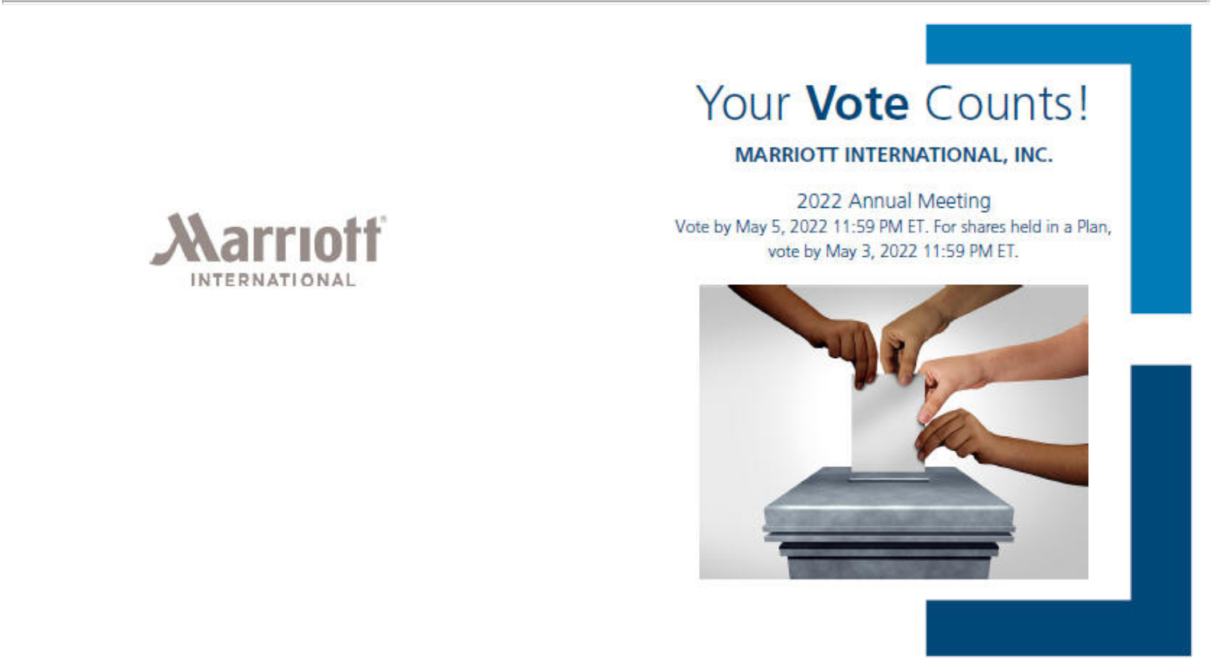

MARRIOTT INTERNATIONAL, INC.
ATTN: KELLY BLACKWELL
10400 FERNWOOD RD.
BETHESDA, MD 20817
LAW DEPARTMENT

D70301-P68475

You invested in MARRIOTT INTERNATIONAL, INC. and it’s time to vote!

You have the right to vote on proposals being presented at the Annual Meeting. This is an important notice regarding the availability of proxy materials for the stockholder meeting to be held on May 6, 2022.

Get informed before you vote

View the Notice and 2022 Proxy Statement and 2021 Form 10-K online at www.ProxyVote.com or scan the QR code below OR you can receive a free paper or email copy of the proxy materials by requesting prior to April 22, 2022. If you would like to request a copy of the proxy materials for this and/or future stockholder meetings, you may (1) visit www.ProxyVote.com, (2) call 1-800-579-1639 or (3) send an email to sendmaterial@proxyvote.com. If sending an email, please include your control number (indicated below) in the subject line. There is no charge to you for requesting a copy. Unless requested, you will not otherwise receive a paper or email copy.
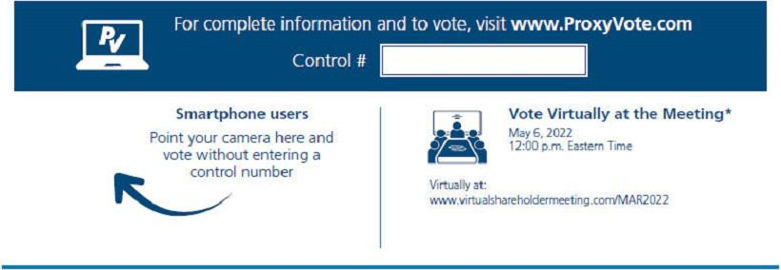

*Marriott International, Inc. (the “Company”) will be hosting the meeting live via the Internet this year at the website address above. Please check the proxy materials for
instructions on how to access the Company’s 2022 Annual Meeting of Stockholders as well as for information regarding how to vote online, by phone or by mail before the meeting. V1.1

Vote at www.ProxyVote.com

THIS IS NOT A VOTABLE BALLOT

This is an overview of the more complete proxy materials that are

available to you on the Internet. You may view the proxy materials at

www.proxyvote.com or easily request a paper copy. We encourage you

to access and review all of the important information contained in the

proxy materials before voting. Please follow the instructions on the

reverse side to obtain the proxy materials and vote on these important

matters.

Board

Voting Items Recommends


- ELECTION OF 12 DIRECTORS

Nominees:

1a. Anthony G. Capuano

1b. Isabella D. Goren

1c. Deborah M. Harrison

1d. Frederick A. Henderson

1e. Eric Hippeau

1f. Debra L. Lee

1g. Aylwin B. Lewis

1h. David S. Marriott

1i. Margaret M. McCarthy

1j. George Muñoz

1k. Horacio D. Rozanski

1l. Susan C. Schwab

- RATIFICATION OF THE APPOINTMENT OF ERNST & YOUNG AS THE COMPANY’S INDEPENDENT REGISTERED PUBLIC ACCOUNTING FIRM FOR FISCAL YEAR 2022

3. ADVISORY VOTE TO APPROVE EXECUTIVE COMPENSATION

4. APPROVAL OF THE MARRIOTT INTERNATIONAL, INC. EMPLOYEE STOCK PURCHASE PLAN

- STOCKHOLDER RESOLUTION REQUESTING THAT THE BOARD PREPARE A REPORT ON THE ECONOMIC

AND SOCIAL COSTS AND RISKS CREATED BY THE COMPANY’S COMPENSATION AND WORKFORCE PRACTICES

6. STOCKHOLDER RESOLUTION REGARDING AN INDEPENDENT BOARD CHAIR POLICY

The Company will be hosting the meeting live via the Internet this year at the website address above. Please check the proxy materials for instructions on how to access the Company’s 2022 Annual Meeting of Stockholders as well as for information regarding how to vote online, by phone or by mail before the meeting.

Prefer to receive an email instead? While voting on www.ProxyVote.com, be sure to click “Sign up for E-delivery”.

D70302-P68475

